# **Telerik Academy**

## **WebServices&Cloud Teamwork**

### **Team Elderberry**

* 1. **Team name and list of team members**

**Team members:**

|  |  |  |
| --- | --- | --- |
| **Name** | **TelerikAcademy account** | **GitHub account** |
| Ани Михайлова | Ani_Mihaylova | ani-mihaylova |
| Бойко Гатев | bgatev | bgatev |
| Венцислав Кулин | kulin_1987 | kulin_1987 |
| Виктор Клисурски | Viktor_Klisursky | Viktor90 |
| Радослав Червенков | Chervenkov | RadoChervenkov |
| Мартин Тонков | m.tonkov | mTonkov |

* 1. **Project purpose**

This application will provide better and easier way of advertising any type of consumer goods, performed by marketing agencies and marketing departments of big companies.

* 1. **Class diagram**

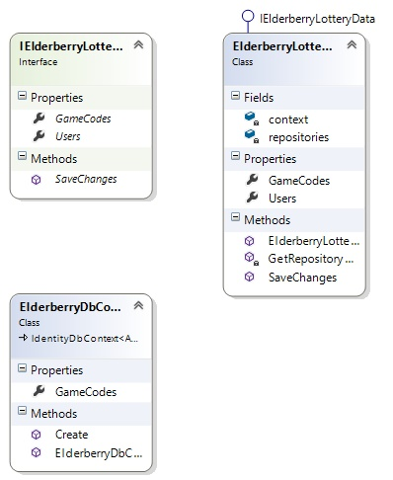

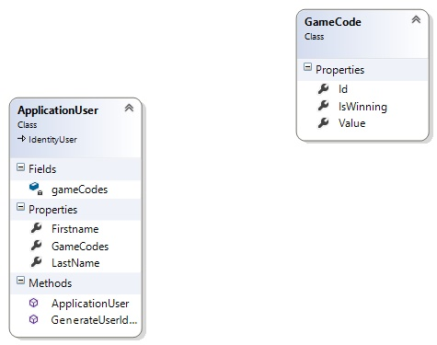

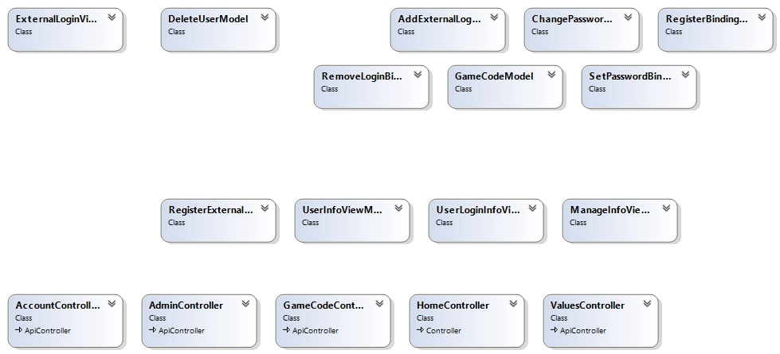

* 1. **The URL of your source control repository**

### ***GitHub : https://github.com/viktor90/Elderberry-Teamwork***